Bayesian Classification Worksheet

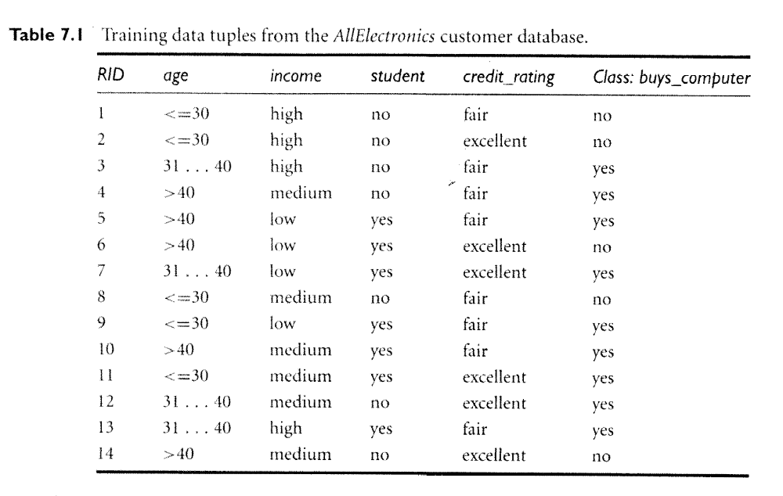

Leave the first four samples out, and then use the remaining 10 samples to calculate the probability that each of the first four samples buys a computer. Use the naïve Bayes classifier that we have been discussing in class.

